Tiruvannamalai District HIV Positive society

Tiruvannamalai

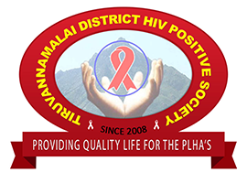

Annual Report
2020-2021

Tiruvannamalai District HIV Positive Society
No.6/29A Pudhu street, 11th street
Polur Road
Tiruvannamalai -606 601

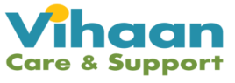

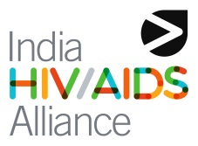

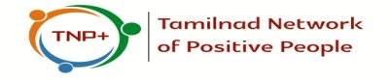

ORGANIZATIONAL PROFILE

Name of Organization: Tiruvannamalai District HIV Positive Society
Office Address 6/29A Pudhustreet, 11th street, Polur Road
Tiruvannamalai – 606 601
Phone : 04175 – 222337
E-mail tdhpsplus@gmail.com
Website :www.tdhplus.in

Board Members of TDHPS+, Tiruvannamalai :

SN. | Name and Contact details | Designation
1 | Mr. Alexander A | President
2 | Mrs. Chandra S | Vice President
3 | Mr. Lakshmi J | Secretary
4 | Mrs. Gandhi A | Treasurer
5 | Mrs. Vitobai E | Executive Member
6 | Mrs. Lalitha M | Executive Member
7 | Mr. Velu R | Executive Member

Society Registration Details.
Date of Registration : Jan 2008
Registration Number : 2/2008
Registered at : Tiruvannamalai
Legal status : Society
Contact Person : Mr. Alexander A,
President – TDHPS+
12AA Certificate No : Sl.No 427/2012-2013
80G Certificate No : DIT(E) No.2(485)12-12
FCRA No : 076080159

BACKGROUND of the DLN
Tiruvannamalai District HIV Positive Society is an organisation exclusive for People Living with HIV/AIDS started from Jan 2008. It aims in providing quality life for the people in Tiruvannamalai District focussing on various aspects like Physical, Mental, Social, Economy, Ecology and Empowerment of women.

The objectives of the organisation are as follows:

- Identify the PLWHA’s.
- It aims in providing quality life for the PLWHA’s.
- Provide accurate and proper information on STD/HIV/AIDS.
- Reduce the Stigma and discrimination.
- Advocate among the key players in preventing the Infection.
- To gives Legal support for property and family problem
- Support Net Group formed
Vision:-

- To give Self Confidence
- Improving the Quality of life
- Advocacy for PLHA’s Problems
Mission:

- Sustainability for all PLHA’s
- Home for PLHA’s
- Own land and Building for Network
- Prevention for HIV
- Any one factory for run by PLHA’s
- Increase the Positive Speaker Skill Development
- Try to get Government Scheme for PLHA’s
- To give Vocational Training for PLHA’s

CORE COMPONENT OF DLN

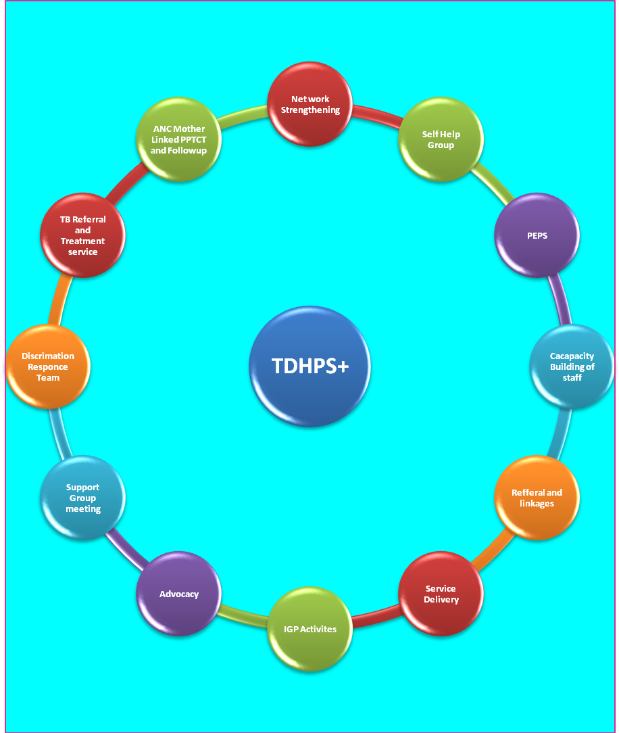

Empowerment, Care & Support:-
- We identifying the PLHA’s around all Tiruvannamalai District.
- Counseling
- We do counseling for their family problem and their needs
- We do family counseling, group counseling, ect.
- Psycho Social Counseling
- Maternal Health & Early Infant Diagnosis Counseling
- Health & Hygiene Counseling
- Sexual & Reproductive Health Counseling
- Adolescent Counseling
- Counseling For Discordant Couple
- Safe Sex Education
- Family Planning
- Counseling on Disclosure
- Peer counseling
- Nutrition counseling
- ART adherence counseling
- OI counseling
- Positive prevention counseling
- Marriage counseling between PLHIVs
- Life Skill Education
- PEPS counseling and referrals for their needs.
  - We do PEPS counseling for their needs and they are become self-confidence.
  - Psycho Social Counseling
  - We do referral for children home for their studies for both infected and affected.
  - We referrer to PLHA’s for Nutrition support
- Motivate the People to take ART
- People are not on ART we refer to test and CD4 and motivate to take ART most of people health is well for ART treatment.

- Home visit for PLHA’s
- We do home visit for PLHA’s home for their permission and give treatment adherence for them
- HIV & TB Co-Infection
- We motivate the people to attend the training for HIV & TB Co-infection. They learned more

Network Strength:-
Ten Support Net Groups were formed inTiruvannamalai district is as follows
S.no | SNG Name | Name of Block | Code Number | Date of Formation | Bank Account
1 | Velicham SNG | Chengam | 330601 | 02.09.2010 | Indian Bank
2 | Vedivallai SNG | Tiruvannamalai | 330602 | 06.09.2010 | Corporation Bank
3 | Vediyal SNG | Polur | 330603 | 26.10.2010 | Indian Oversiers Bank
4 | Udiyam SNG | Thurijapuram | 330604 | 19.11.2010 | Corporation Bank
5 | AnnaiTherasa SNG | Pudhupalayam | 330605 | 22.02.2011 | Union Bank
6 | Pattu SHG | Arni | 330606 | 10.07.2011 | Candra bank
7 | Sutaroli | Thandrampet | 330607 | 12.09.2012 | Indian Bank
8 | Deepaoli | Tiruvannamalai | 330608 | 08.03.2013 | Corporation Bank
9 | Olivelakku | Vettavalam | 330609 |  | Processing
10 | Padikarukkal | Tiruvannamalai | 330610 |  | Processing

Projects at DLN a Glance:
Sl:No | Project | Objective | Project Period | Supported by
1 | Vihaan Project | Improve the survival and quality of life of PLHIV” | April 2013 to December 2017  &  Jan 2018 to March 2022 | Alliance India

Background of Vihaan project

India revamped care and support strategies in 2013 under NACP IV. Govt. has taken all treatment including OIs and care and support services is taken care by civil society organizations. India HIV/AIDS Alliance became Principle Recipient (PR) for care and support programme. Vihaan (Sanskrit word which means dawn’s first light) care and support programme is implemented across India from 2013 onwards. The main goal of the programme is improving quality of life and survival of PLHIV. The programme being implemented with 21 Sub Recipient (SR) partners and 350 CSCs.

The operational guidelines was developed keeping care and support needs in focus and the guidelines developed in consultation with PLHIV community organization, subject experts from various streams and departments. NACO published this guidelines in December 2013. The programme has evolved over the years and certain changes had taken place in its approach and strategies when the programme based on policy changes and changing needs at field level. Moving forward to next phase (2021-2022) furthermore changes expected in view of the roll out ofNational policy of Test and Treat and also in the pipeline of implementing ‘differentiated care model’ towards accomplishment of 95:95:95 strategy and changing in funding pattern .Considering the changes in the strategy, approach and service delivery modes, certain changes proposed to care and support in care and support guidelines. Once these changes are accepted, same will be incorporated in guideline document.

Vihaan objectives
Specific objectives of the programme include:
- Early linkages of PLHIV to Care, Support and Treatment services: The CSC will support PLHIV who have newly tested positive to enrol into the ART programme.
- Improved treatment adherence and education for PLHIV:Adherence education and support can help the PLHIV sustain and manage their treatment regimes. It is essential that all three elements of successful treatment are supported: the client, the provider, and the process.
- Expanded positive prevention activities: Improved positive prevention will contribute to the national efforts to prevent HIV transmission and reduce overall burden of disease.
- Improved social protection and wellbeing of PLHIV: Social and economic well-being is an important component of care and support. The CSC will facilitate access to the existing social welfare and protection schemes under different line departments, Corporate Sector, Public Sector Undertakings, Faith Based Organisations and civil society organization.
- Strengthened community systems and reduced stigma and discrimination: To ensure a robust system that supports the program goal and ensures stigma and discrimination free access to quality services, it is important that skills of the community members to advocate are strengthened. Establishing community systems like community advisory board (CAB) and discrimination response team (DRT) will bring in sustainable response.
Care and Support Centre (CSC)
Changes in the Strategy:

Provision of Differentiated Care:

Differentiated care is a client-centred approach that simplifies and adapts HIV services across the cascade to reflect the preferences and expectations of various groups of people living with HIV (PLHIV) while reducing unnecessary burdens on the health system. By providing differentiated care, also called differentiated service delivery, the health system can reallocate resources to those most in need.
Differentiated care aims to enhance the quality of the client experience. It puts the client at the centre of service delivery. It also ensures the health system functions in both a medically accountable and efficient manner. The central driver to adapting service provision is the client’s needs. In line with WHO guidelines, clients are categorized in to 3 major categories based on their clinical characteristics, vulnerabilities, gender, age and socio-economic conditions which are explained below:
Service package:

Similar to treatment, care and support requirement of PLHIV is varying and all the clients do not require similar attention. Care and support services should complement the treatment and retention in care.

NETWORKING AND LINKAGES

SSR Tiruvannamalai CSC Team Organogram

Current HIV statistics at Tiruvannamalai
- The Tiruvannamalai District consists of 26,04,569 in population
- 7,240 is the estimated PLHIV in the district of Tiruvannamalai
- 6195 PLHIV have been registered in Tiruvannamalai ART center.
- 6020 PLHIV are Adhering to ART.
Children enrolled in Tiruvannamalai CSC Total 219 Children
- On ART PLHIV children Enrollment our CSC Male 67, Female 69
- Pre ART PLHIV children Enrollment our CSC Male 38,Female 54
- HIV affected and Infected children in their family Male 580, female 510
Activities I – a – Number of new PLHA enrolled

- To speak out openly we are the HIV positive we are living healthy so you don’t worry about HIV We will be with you.
- To identified the client through field visit

Enrollment up to March 2021  A1 | Enrollment in ART Centre  (Alive on Client)  A2 | Percentage achieved  =A1/A2
4831 | 3123 | 72%

Enrollment 01.06.2013 To 31.03.2021 Total CSC Enrollment

REGISTRATION
Gender | 2013 - 2014 |  | 2014 - 2015 |  | 2015 – 2016 |  | 2016 – 2017 |  | 2017 – 2018 |  | 2018-2019 |  | Total
Gender | Pre ART | On ART | Pre ART | On ART | Pre ART | On ART | Pre ART | On ART | Pre ART | On  ART | Pre  ART | On  ART | Pre ART | On ART
Male | 125 | 376 | 182 | 387 | 162 | 177 | 110 | 200 | 71 | 116 | 70 | 114 | 720 | 1370
Female | 174 | 435 | 185 | 331 | 105 | 136 | 80 | 201 | 45 | 107 | 37 | 128 | 626 | 1338
TG | 1 | 1 | 3 | 1 | 0 | 0 | 0 | 0 | 0 | 0 | 0 | 0 | 4 | 2
Male Children | 15 | 23 | 13 | 22 | 3 | 6 | 2 | 7 | 4 | 3 | 1 | 8 | 38 | 69
Female Children | 24 | 19 | 23 | 8 | 0 | 8 | 2 | 9 | 0 | 1 | 1 | 4 | 50 | 50
Total | 339 | 854 | 406 | 749 | 270 | 327 | 194 | 417 | 120 | 227 | 109 | 254 | 1438 | 2828

Enrollment 01.04.2020 To 31.03.2021 Total CSC Enrollment

REGISTRATION
Gender | 2019 - 2020 |  | 2020-2021 |  |  |  |  |  |  |  |  |  | Total
Gender | Pre ART | On ART | Pre ART | On ART |  |  |  |  |  |  |  |  | Pre ART | On ART
Male | 118 | 70 | 52 | 67 |  |  |  |  |  |  |  |  | 852 | 1494
Female | 78 | 58 | 44 | 69 |  |  |  |  |  |  |  |  | 711 | 1562
TG | 0 | 0 | 0 | 0 |  |  |  |  |  |  |  |  | 4 | 2
Male Children | 3 | 0 | 0 | 4 |  |  |  |  |  |  |  |  | 41 | 73
Female Children | 1 | 4 | 2 | 2 |  |  |  |  |  |  |  |  | 53 | 56
Total | 200 | 132 | 98 | 142 |  |  |  |  |  |  |  |  | 1661 | 3187

I- E – services provided through -Outward referral (01.04.2020 to 31.03.2021)

Outward Referral (01.04.2020 – 31.03.2021)
Gender | ART Center | ICTC Center | DOTS Center | STI Clinic | Cervical Cancer Testing | Welfare Schemes | Total
Male | 502 | 9 | 142 | 0 | 0 | 72 | 655
Female | 390 | 8 | 125 | 0 | 0 | 53 | 576
Male Children | 10 | 7 | 4 | 0 | 0 | 11 | 32
Female Children | 14 | 9 | 2 | 0 | 0 | 18 | 34
Total | 916 | 33 | 273 | 0 | 0 | 154 | 1297

Clients attended Support group meeting in each Thematic areas
During this year we conducted 20 meeting for these support group Meeting
Support Group Meeting 2020 – 2021
 | Basic health and Hygiene | Diet and nutrition | OI management and co-infection | Treatment education /adherence | Social entitlements and livelihood | Total
Total Number of Meeting contact | 1 | 4 | 4 | 5 | 6 | 20
Male | 5 | 16 | 26 | 23 | 27 | 97
Female | 7 | 33 | 20 | 35 | 43 | 138
Male Children | 0 | 0 | 0 | 0 | 0 | 0
Female Children | 0 | 0 | 0 | 0 | 0 | 0

Outcome of Support group meeting
102 Members Linked to UPT Pension Schemes
2 Members linked to Welfare (Tailoring machine)
- 5 Member linked TAHDCO Loan schemes
- 29 Children linked OVC Fund
- 6 Members linked Widow pension
- 43 Children’s linked Nutrition schemes. 34 Children’s linked Education support
- 6 Member linked Pasumaiveeduthittam
- Client are Visit the TDHPS+ office regularly
- They are shared all problem’s for PLHA’s
- Knowledge update for .ART Adherence treatment and OI management
- Defaults clients were identified and now they are going for regular treatment.
- O I Clients were referred for the treatment by ORW/Peer counselor.
- Support group meeting attend participant said that “ They support group meeting we forget about our disease and we actively participating in the group meeting with joy, now a days we are going to regular treatment from ART also

SUPPORT GROUP MEETING SUPPORT GROUP MEETING
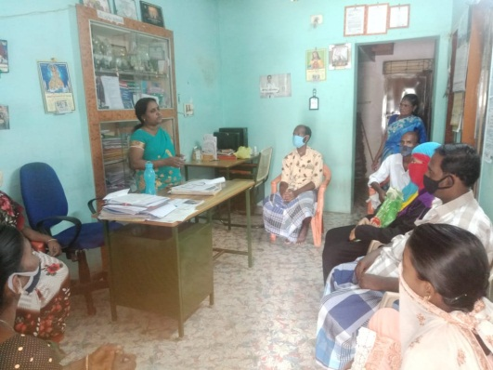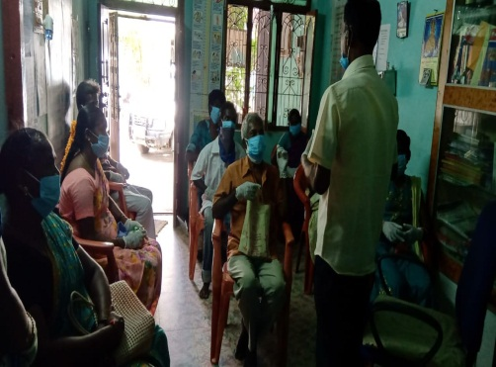

Advocacy Meeting
During this year Four Advocacy meetings were conducted. Four meetings were conducted ICDS staff (Anganwadiwadi worker), Helping mind and good cooperation were raised among Panjayet president, Block development officer and Local business people
- Pasumaiveeduthittam 18 members revived. AAY schemes 35Kgs rice received 241 Members and 20 person received old age pension schemes also person referring from TDHPS+
- 7 Person received Tailoring machine.
- stigma and decimation reduce and media people supported for CSC programme
- ICDS staff are accepted to need based help for HIV infected childrens
Coordination Meeting
- ART – CSC Coordination Meeting Every month at Tiruvannamalai ART center
- DPACU Review meeting every month
- HIV – TB coordination meeting every month at Tiruvannamalai TB center
- NGO coordination meeting at Tiruvannamalai LWS Programme

ART – CSC CORDINATION MEETINGDAPCU REVIEW MEETING
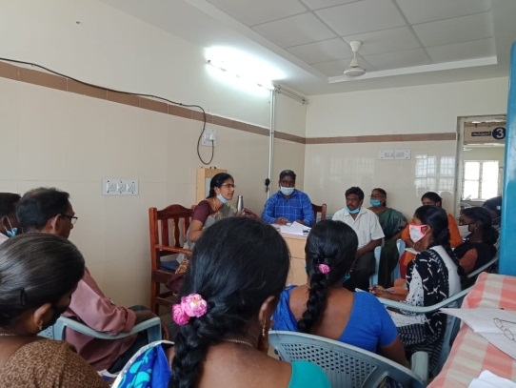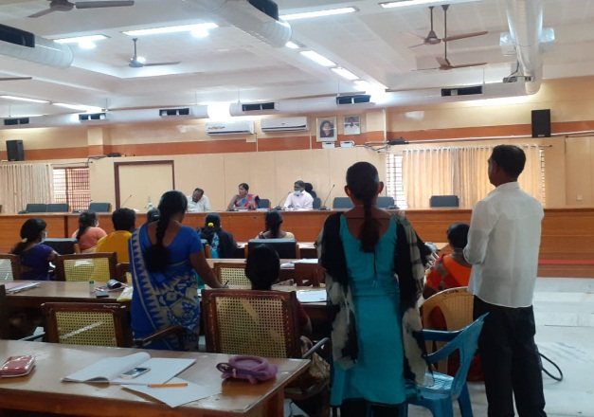

World AIDS Day Programme

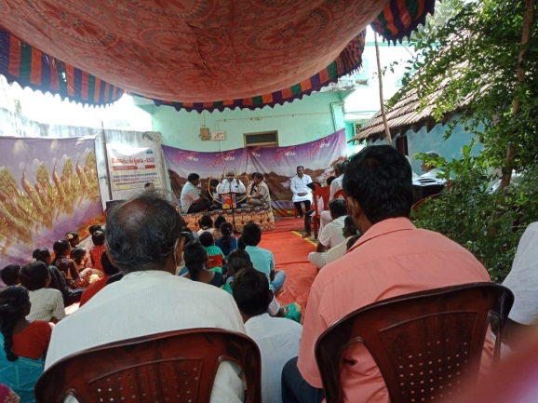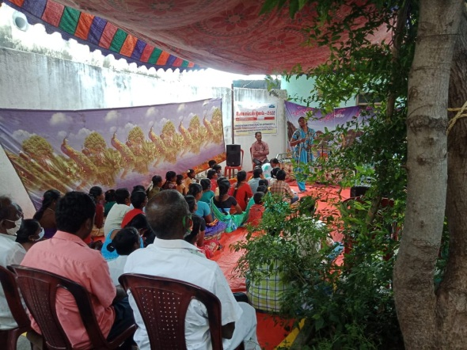

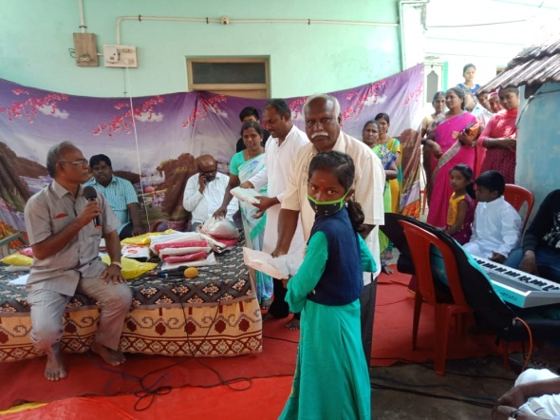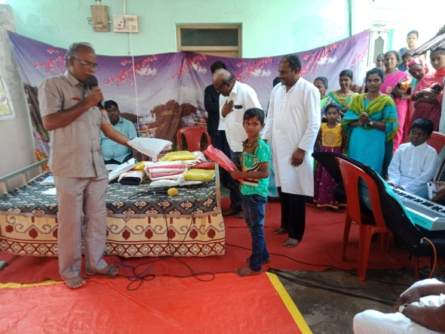

Nutrition Support

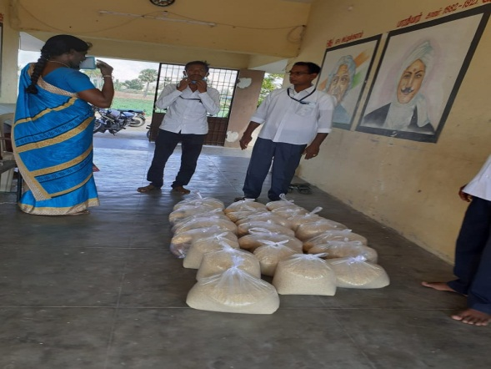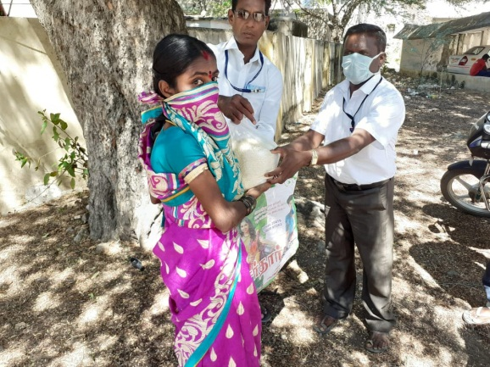

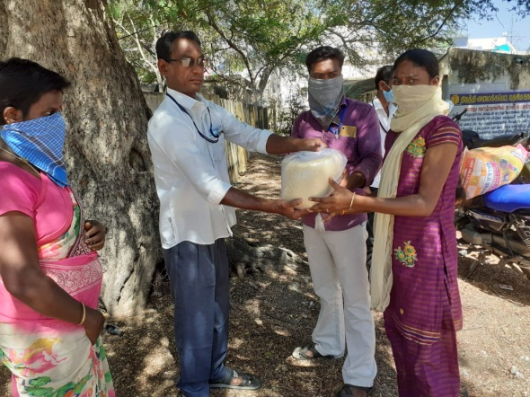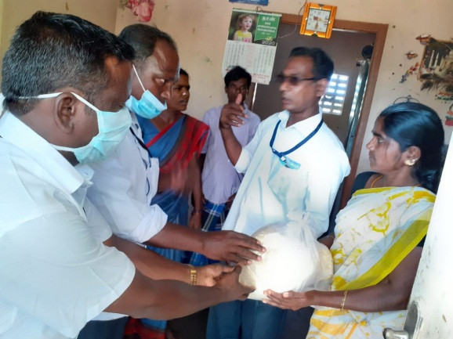

COVID-19

In Tiruvannamalai District from starting stage of Covid-19 curfew till now CSC PCO,PD and Outreach workers coming to office and also call to the Client. ORW’s are shift basic / Rotation going to ART Centre. All workers give awareness to the client with Safety Precaution and also call to the client in order to take tablet through nearby Link ART Centre.
In ART they provide Mask and hand gloves to the workers. ART Medical officer asked workers call to the client safety measures. CSC Staffs asked client through phone call whether buy tablet or not. If client unable buy tablet means staff buy tablet from ART and give it to the home delivery.
Tiruvannamalai ART Centre does not provide client list to the CSC. Art centre willingly client they provide 22 client list. PD and Peer counsellor and ORW’s give tablet to the home delivery .After that they provide 44 client list, for that also tablet gave to the staffs home delivery.
CSC Staffs call to nearby Link Art who the client buy tablet or not. If client not buy tablet then once again call to the client ensured to be csc staffs asked through whetherbuy tablet or not.If client unable buy tablet means staffs buy tablet from Art and give it to the home delivery. Art does not provide line list to the csc.
So for 30 families provided the Rice and Nutrition support product through DAPCU. ART provide gloves and Mask and slso insist field workers to wear it.
We are happy to give tablet to the Positive people during COVID-19 . In tiruvannamalai line list gave to csc they are willing give tablet to the client.

Till date phone conduct client - 1322
Take the tablet client - 545
Home delivery - 82
Priority line list received - 396

Drug Issued Photos

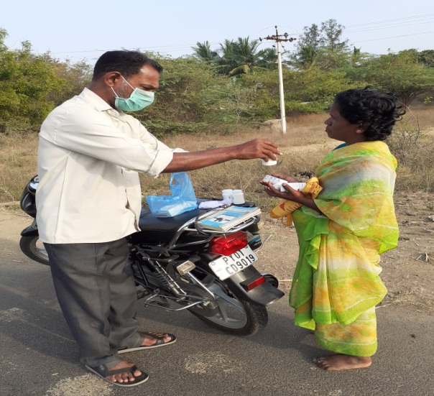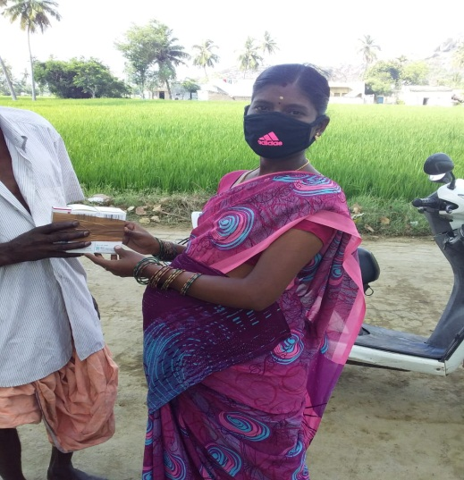

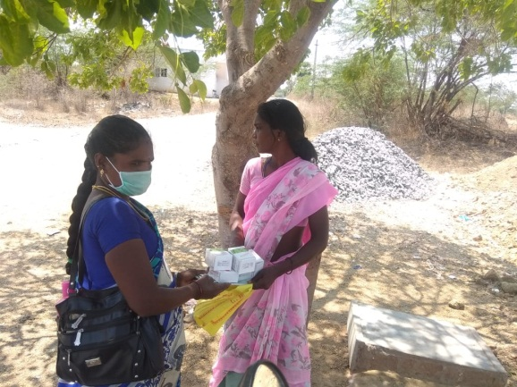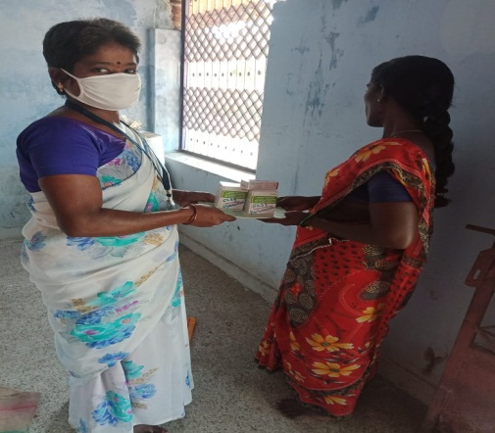

Welfare SCHEMES 2020

August -2020 DAPCU and CSC Discus Social welfare Schemes. CSC Staffs call the clients and Eligible person Come to the office . September -20 Application Sent to DAPCU office
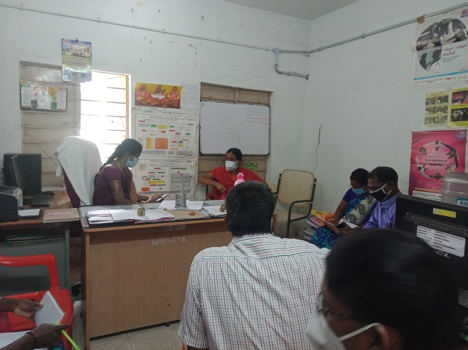 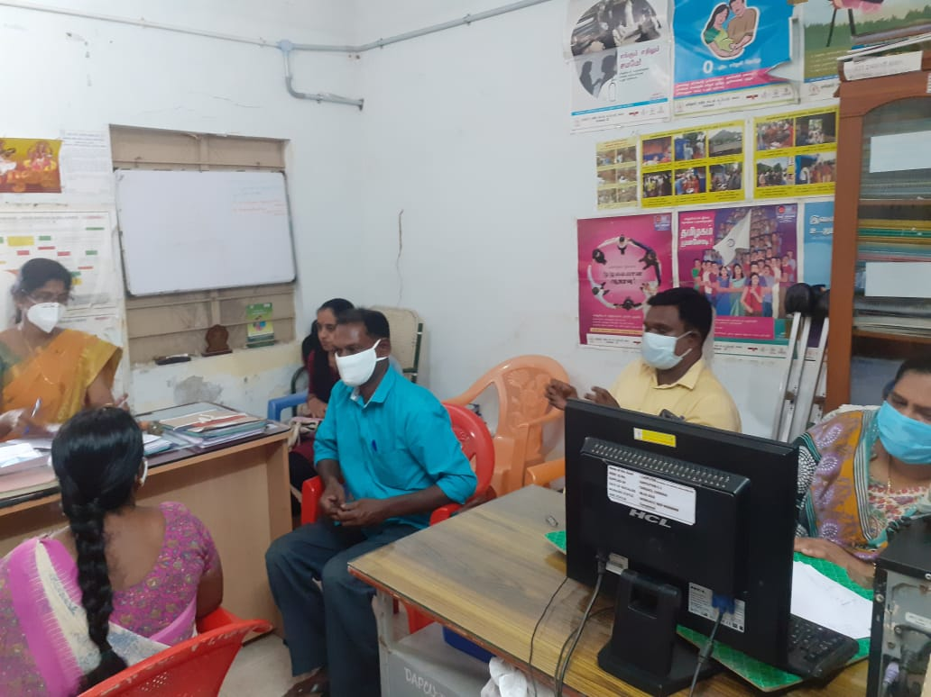

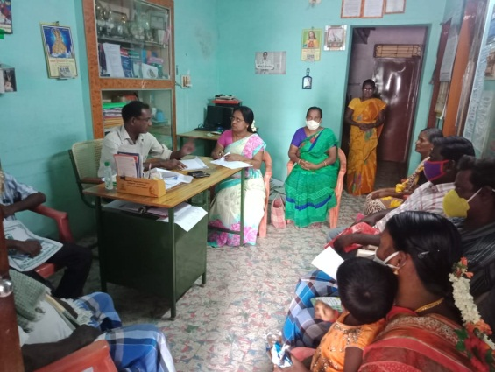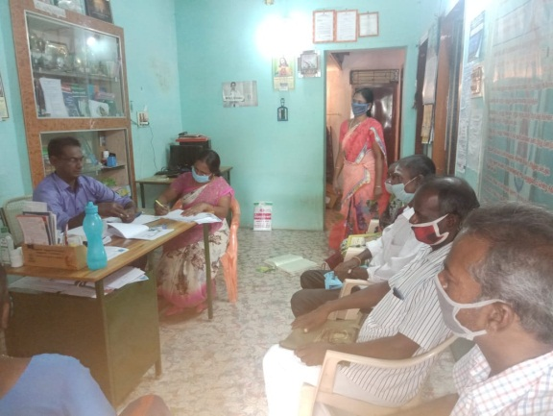

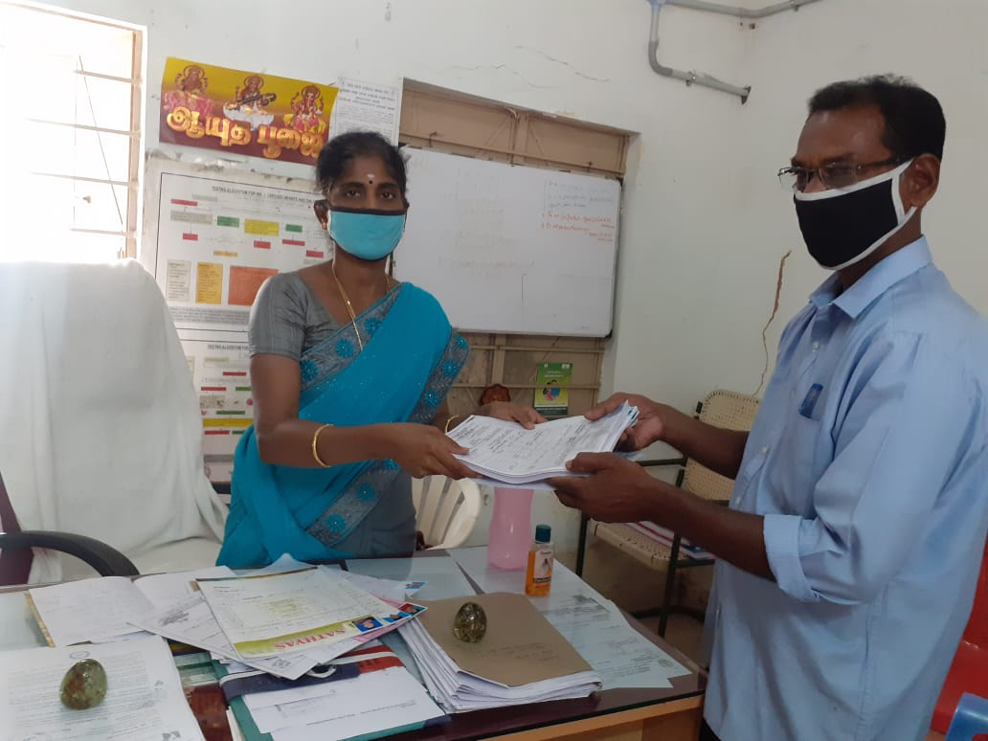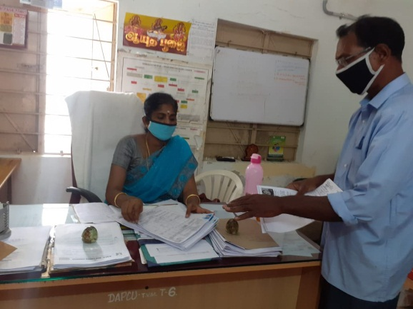

RRC Programme at Kamban College
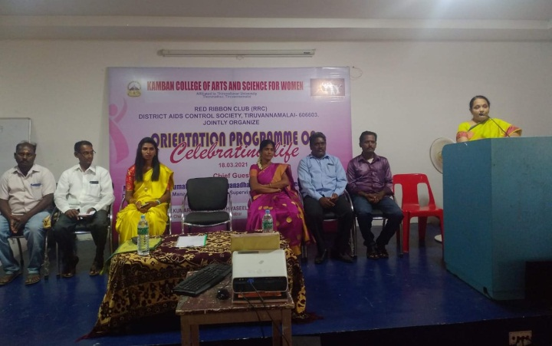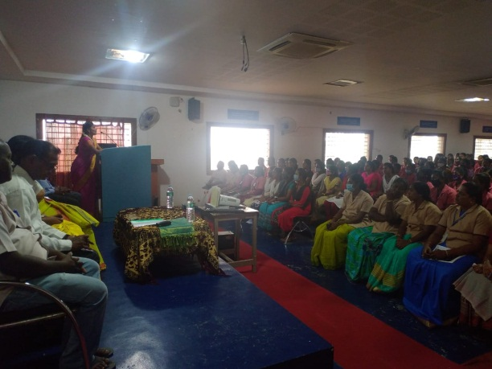

Rotary Club’s givingGoat,Trolle and TiffianMatrials
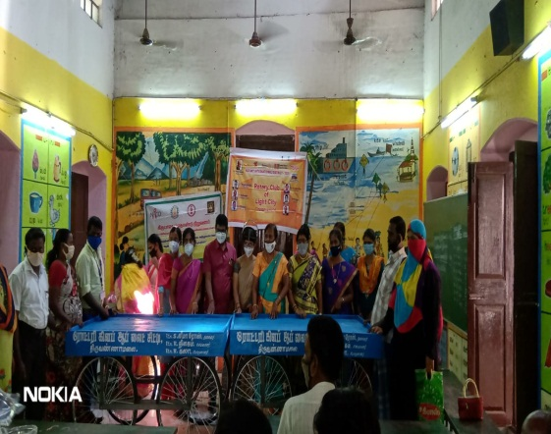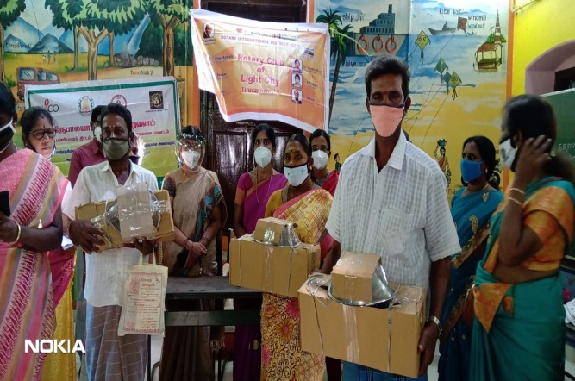

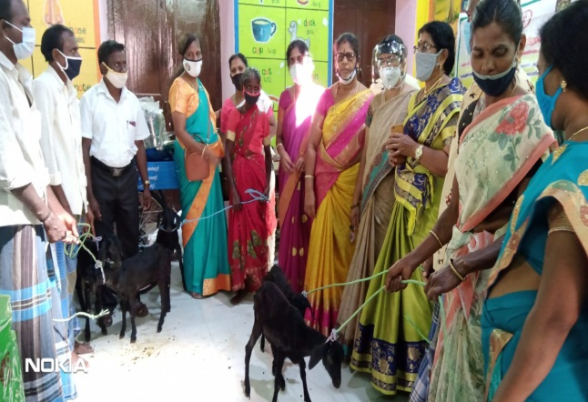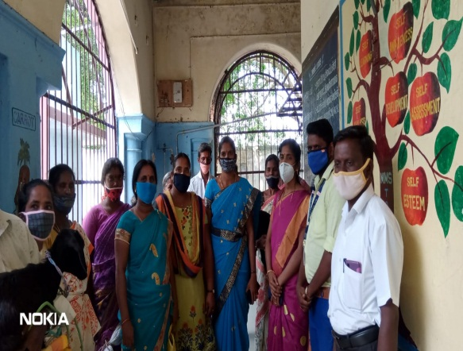

Proposed Strategy for Popularizing CSC in the District
- DAPCU Monthly review meeting time they are explain Vihaan project and CSC actives all ICTC counselor, TB Hospital STO, STLS, DPPM and Lab Tech.,
- Vihaan project and CSC actives explained the Link Workers scheme Project NGO and PPTCT programme NGO review meeting.
- Deepam festival time two days awareness both contacted that time IEC banner for Vihaan project and CSC actives displayed. General public see 1500 more than and 100 people were see awareness both explained the Vihaan project and CSC actives.
- DRT team member explained the Vihaan project and CSC activies in the meeting for Lion’s club, Rotary club and RRC programme.
- Anganwadi Worker training at block level 3 meeting contact Tiruvannamalai CSC. at the time PCO participant and explained for Vihaan project and CSC actives in Angawadi worker asked to For the need of CIA and they accepted to provide it on need based. first priory for PLHA”S in the Tiruvannamalai district

SOCIAL WELFARE SCHEMES
SOCIAL WELFARE SCHEMES AS ON 31.03.2021
S.No. | Name of the Schemes | 01.04.2008 – 31.03.2017 Beneficiary | 01.04.2020 –31.03.2021 Beneficiary | Total Number of Beneficiary
SOCIAL WELFARE SCHEMES
1 | TAHDCO Loan | 164 | 5 | 169
2 | Antyodaya Anna Yojana (AAY) | 241 | 0 | 241
3 | Old age pension | 21 | 3 | 24
4 | Widow Pension | 18 | 6 | 24
5 | PudhuVazhuThittam | 131 | 0 | 131
6 | Pension (UzharpadhukapuThittam) | 163 | 102 | 265
7 | Children’s Education Support | 422 | 20 | 442
8 | OVC Fund | 170 | 29 | 199
9 | Children’s Linkage to Hostel | 45 | 0 | 45
10 | Nutrition Support | 771 | 40 | 811
11 | Job in Placement | 33 | 2 | 35
12 | Tailoring mechine | 13 | 2 | 15
13 | PusumaiVeedu | 13 | 6 | 19
14 | Self Help Group Loan | 110 | 0 | 110
15 | Bus Pass | 50 | 5 | 55
16 | Railways Pass | 1 | 0 | 1
17 | Star Health Insurance (Children's) | 25 | 0 | 25
18 | Funeral service | 17 | 0 | 17
TOTAL |  | 2408 | 220 | 2628
SOCIAL ENTITLEMENT
1 | Income Certificate | 69 | 6 | 75
2 | Caste Certificate | 63 | 4 | 67
3 | Nativity Certificate | 41 | 1 | 42
4 | Ration Card | 1 | 0 | 1
5 | Disability Certificate | 3 | 0 | 3
6 | Bank Account | 18 | 2 | 20
7 | Post Office Account | 14 | 0 | 14
TOTAL |  | 209 | 13 | 222

TAHDCO Loan
- Belongs to Tiruvannamalai District HIV Positive Society, we recommended 18 member and The District Collector to give (TAHDCO Loan) small Scale Industry (Petty Shop and Cutpiece Center)and benefactors
We do Awareness Program to General Public
- We do awareness for General Public through Deepam Festival Awareness programme, World AIDS Day celebration, RRC programme and world TB Day celebration
- We attend the NGO Co-Ordination Meeting and District Advisory Committee Meeting
We create rapport with Government and Non Government Organization

Any activities related Sustainability? Future plan for sustainability?

- Try to get vocational training for PLHA’s
- Strengthening the Children welfare fund’s through women’s forum
- We will arrange for network own building
- We will arrange for Children higher education through Society
- We motivate the people to take ART without Defaulter.
- To sustainability through Support Net groups for own business

Challenges faced? Way to overcome the challenges? Expectation to overcome the Challenges?

- ARTC share the LFU and Missed client name list repetition (Migrant and incorrect address name)
- Client outreach purpose go to long distance (Cheyyar, Jawhed hills and vandhavasi) totally traveled up and down 180 Kms

Whether quality of PLHA Life improved or not?

- New Vision Foundation - Chennai issued 50 Members received nutrition food (Quality Rice).
- New Vision Foundation – Chennai issued 50 Children’s received Education support
- Rotary Club’s and TDHPS+ issued 50 member HIV infected Children’s and PLHA’s received for Rice, bedsit and Nutrition at time of world AIDS Day 2020programme.
- Belongs to Tiruvannamalai District HIV Positive Society, we recommended 5 member and The District Collector to give (TAHDCO Loan) small Scale Industry (Petty Shop, and Cut piece loan) and Sewing machine

Drop-in-Centre Project:
This AGREEMENT shall remain in FORCE from 01.11.2020to 31.03.2021 unless terminated earlier in accordance with the provision of this AGREEMENT or in the event the period is extended through a mutually agreed amendment to this AGREEMENT. The total duration of the AGREEMENT including extension, if any, shall not exceed a period of 31.03.2021. Moving forward to next phase (2021-2022)

- Services of the Drop-in-Centre Project:
- Provide sustainable counseling and support services to people living with HIV/AIDS (PLHIV)
- Organize support group meetings for PLHIV
- Provide psychosocial support to PLHIV.
- Linkages with Care and support service providers and linkage with Govt Schemes.
- Assisting them in coping with socio – economic – psychological issues.
- Create an enabling environment for obtaining services from the Govt and Private Institution.
- Abide by the principles and framework of NACP IV

Conclusion

Through the Vihaan – Care and support center Project we are sustainable Documentation, Referral Linkages, Capacity Building, CMIS, Support net group Metting and programme We are also able to identify more and more people living with HIV/AIDS day by day and able to provide the core components that is Networking, Advocacy and service delivery.

